Anoushka Divekar
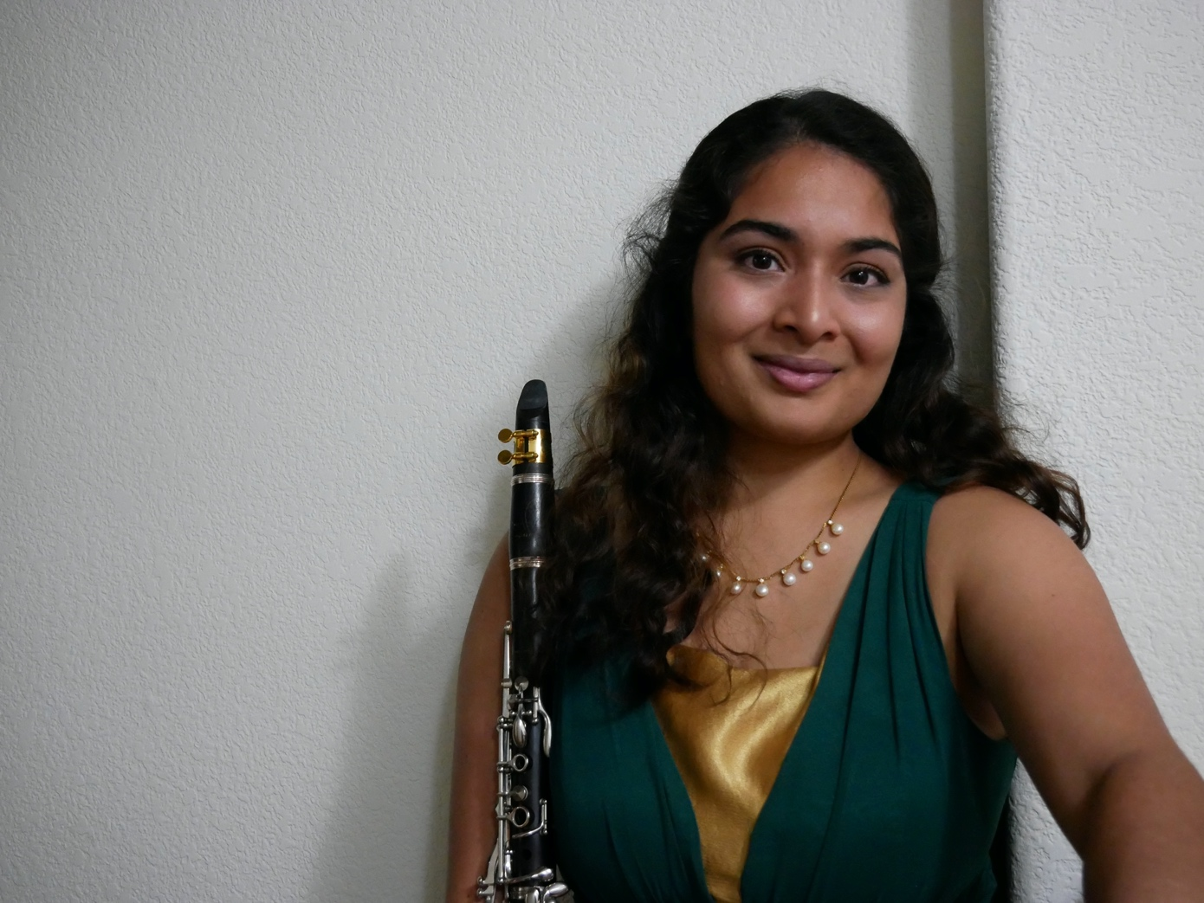

Clarinet Repertoire List

Updated June 2021

Ayola, Edward L.
Winning Rhythms$
Baermann, C.
Complete Method for Clarinet Book III$
Baiocchi, Regina A. Harris
Karibu@
Chasse#
Feathers and Bowties#
Bassi, Luigi
Concert Fantasia on Motives from ‘Rigoletto’#
Barber, Samuel
First Essay for Orchestra*
Violin Concerto Op. 14*
Bartók, Béla
The Miraculous Mandarin^
Beach, Amy
Pastorale%
Beethoven, Ludwig Van
Overture to the Creatures of Prometheus*
Symphony No. 6 in F Major, Op. 68 ^
Symphony No. 8 in F Major, Op. 93^
Berlioz, Hector
Symphonie Fantastique^
Bizet, Georges
Carmen Suite*
Bloch, Ernest
Schelomo*
Borodin, Alexander
Polovtesian Dances^
Brahms, Johannes
Clarinet Quintet in B minr, Op. 115@
Sonata in E flat Op. 120 No.2#
Symphony No. 3*
Trio for Clarinet, Piano, and Cello Op. 114@
Bricusse, Leslie et al.
Willy Wonka&
Britten, Benjamin
March No. 1*
Bernstein, Leonard
Overture to Candide*
Sonata for Clarinet and Piano#
Bona, P.
Complete Method for Rhythmical Articulation$
Boulanger, Lili
D’un matin de Printemps*
Boykin, Brittney
Quest#
Cahuzac, Louis
Arlequin%
Chopin, Frederic
Piano Concerto No. 1*
Coleridge-Taylor, Samuel
Clarinet Quintet, Op. 10@
Coleman, Valerie
Portraits of Langston#
Rubispheres#
Copland, Aaron
Billy the Kid*
Variations on a Shaker Melody from ‘Appalachian Spring’*
Concerto for Clarinet@
Creston, Paul
Night in Mexico*
Custer, Calvin
The American Frontier*
David, Ferdinand
Concertino for Trombone and Orchestra*
Debussy, Claude
La Mer*
Premiere Rhapsodie@
Denny-Chambers, Kristen
Prep Steps Before You Kroepsch$
Dufrense, Gaston
Develop Sight Reading$
Dvorak, Antonin
Symphony No. 8*
Frescobaldi, Girolamo
Toccata*
Filas, Thomas
Top Register Studies for the Flute$
Françaix, Jean
Clarinet Concerto#
Gaffney, Jack
Neon Tetra@
Gershwin, George
Rhapsody in Blue^
Glinka, Mikhail
Russlan and Ludmilla Overture*

Heim
Practical Approach to the Altissimo Register$
Hindemith, Paul
Kleine Kammermusik für fünf Blaser@
Symphonic Metamorphosis*
Hite, David
Seven Grand Concert Duets$
Melodious and Progressive Studies Book I and II $
Ibert, Jacques
Trois Pieces Breves#
Khachaturian, Aram
Masquerade Suite*
Kovacs, Bela ­
Hommage à J.S. Bach%
Hommage à M. de Falla#
Hommage à R. Strauss#
Kroepsch, F.
416 Clarinet Studies$
Larsen, Libby
Dancing Solo@
Lutoslawski, Witold
Dance Preludes#
Mahler, Gustav
Symphony No. 5*
Martino, Donald
A Set for Clarinet #
Mendelssohn, Felix
Elijah*
Midsummer Night's Dream 'Scherzo'^
Symphony No. 3, Op. 56 'Scottish'^
Messager, Andre-Charles
Solo De Concours%
Mozart, Wolfgang Amadeus
Clarinet Concerto in A, K. 622#
Serenade for Winds K375#
Nielsen, Carl
Clarinet Concerto%
Wind Quintet%
O’Keefe, Laurence et al.
Legally Blonde&
Osborne, Wilson
Rhapsody#
Poulenc, Francis
Sonata for Clarinet and Piano@
Sonata for Two Clarinets@
Powell Perry, Zenobia
Sonatine for Clarinet and Piano@

Prokofiev, Sergei
Quintet Op. 39#
Romeo and Juliet*
Puccini, Giacomo
Tosca^
Rabaud, Henri ­
Solo de Concours#
Ravel, Maurice
(arr. Jones, Mason)
Tombeau de Couperin Wind Quintet#
Daphnis et Chloe^
Reicha, Anton
Quintet in Eb Op.88 for Winds#
Respighi, Ottorino
Pini di Roma*^
Trittico Botticelliano*
Rimsky-Korsakov, Nikolai
Capriccio Espagnole^
Scheherazade^
Rodgers, Richard and Hammerstein, Oscar
Cinderella&
Oklahoma Selections*
Rose, Cyrille
32 Etudes and 40 Studies for Clarinet$
Rossini, Gioacchino
Introduction, Theme and Variations%
Rubank
Advanced Method for Clarinet Book I and II$
Saint-Saens, Camille
Sonata#
Schubert, Franz
Unfinished Symphony No. 8 in B Minor*
Schumann, Robert
Fantasiestuck#
Symphony No. 2*
Sherman, Richard M et al.
Mary Poppins&

Shostakovich, Dmitri
Symphony No. 5^
Symphony No. 9^
Sibelius, Jean
Pelleas and Melisande Suite*
Symphony No. 1^
Srinivasan, Asha
Alone, Dancing#
Strauss, Richard
Der Rosenkavalier Suite*
Concert No. 1 for Horn*
Till Eulenspiegel’s Merry Pranks^
Stravinsky, Igor
Firebird Suite (1919)^
Octet #
Petrouchka*
Three Pieces for Clarinet Solo@
Strouse, Charles
Annie&
Sutermeister, Heinrich
Capriccio for Solo Clarinet in A@
Verdi, Guiseppe
Nabucco Overture*
Voxman, H.
Selected Duets Book II$
Selected Studies$
Ware, Lawren Brianna
Recollection and Anticipation#
Weber, C. M. von
Concertino#
Concerto No. 1#
Concerto No. 2#
Variations#
Widmann, Jörg
Fantasie@
Yaus, Grover C.
101 Rhythmic Rest Patterns$

